# Acknowledgement

I amsincerely and heartily grateful to my friend, Erik Van Der Boom who guides me throughout the coursework development. I was struggling with the coursework and was initially trying to develop the coursework with the lecture’s method. He is the one who made me believe in myself and suggest me a better way of developing the coursework. I am sure that this coursework would have not been possible without his support, understanding and encouragement. Besides that, I would also like to show my gratitude to my parents, friends and classmates for their help and moral support.

# User Guide

# Main Menu Screen

1. Press at the mines that display in the main menu screen to start the game.
2. Press the difficulty button to change the game difficulty.
3. Press the leader board button to view leader board score.
4. Press back button to exit or go to previous screen.

# Game Play Screen

1. Press any empty tile to make a move.
2. Press the marker button to pick up a marker and place it in any empty tiles that you wanted to place.
3. Press on any marked tile to remove the marker.
4. Press start over button again if you wish to restart the game.
5. Press back button to main menu screen.

# The Game

Find the empty squares while avoiding the mines. The faster you clear the board, the better your score.

**The Board**

Minesweeper has three standard boards to choose from, each progressively more difficult.

**Easy:** 81 tiles, 10 mines

**Medium:** 144 tiles, 20 mines

**Hard:** 256 tiles, 40 mines

**How to play**

The rules in Minesweeper are simple:

* Uncover a mine, and the game ends.
* Uncover an empty square, and you keep playing.
* Uncover a number, and it tells you how many mines are hidden in the eight surrounding squares—information you use to deduce which nearby squares are safe to press.

**Hints and tips**

**Mark the mines.** If you suspect a square/tile conceals a mine, press on the market button and place the marker on the square. (If you're not sure, you may press the marker that you just placed then it will be remove.)

**Study the patterns.** If three squares/tiles in a row display 2-3-2, then you know three mines are probably lined up beside that row. If a square/tile says 8, every surrounding square is mined.

# Screenshot

# Start Game

# C:\Users\YongPin\Desktop\Project Screenshot\Little Minesweeper\Main Menu.pngC:\Users\YongPin\Desktop\Project Screenshot\Little Minesweeper\Main Menu Medium.pngC:\Users\YongPin\Desktop\Project Screenshot\Little Minesweeper\Main Menu Hard.png

Figure 1.0 Start Up screen which allows users to change difficulty, view high score and enter the game screen.

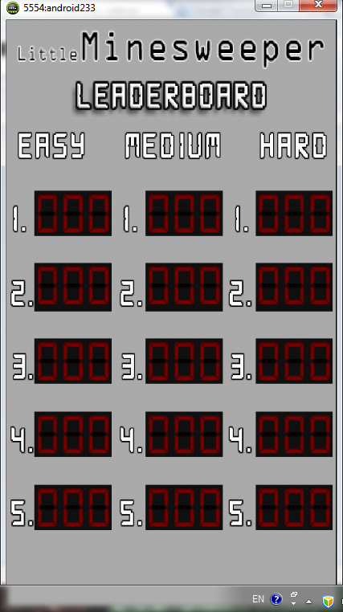

Figure 2.0 Leader board screen.

# Game Screen

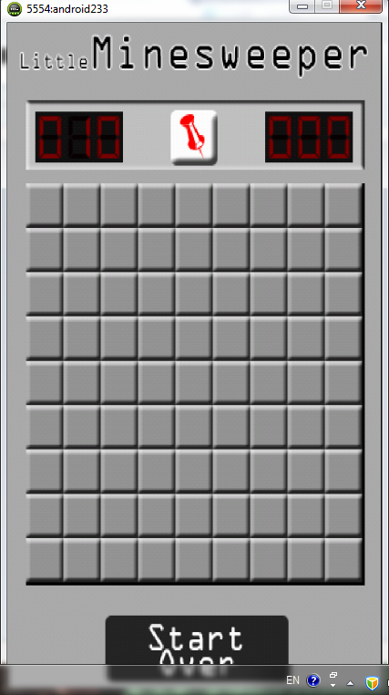  
Figure 3.0 Game screen.

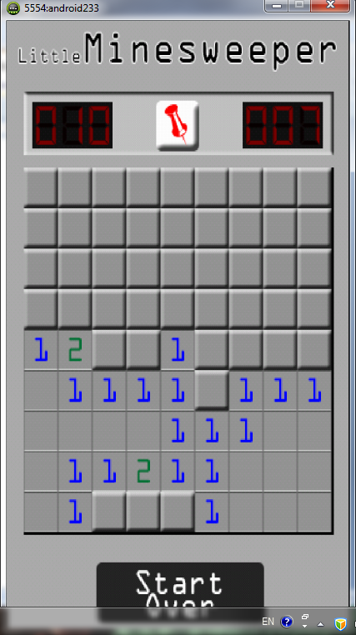

Figure 4.0 Middle game play screen.

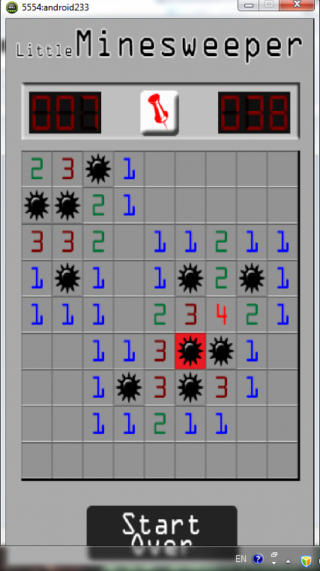

Figure 5.0 End of the game screen.

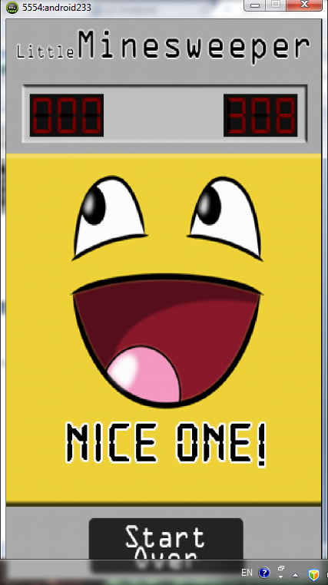

Figure 6.0 End of the game winning screen.

# References

1. Mario Zechner (2011). *Beginning Android Games*. London: Apress. p185 - 641.
2. J. F. DiMarzio (2011). *Practical Android 4 Games Development*. London: Apress. p1 - 299.